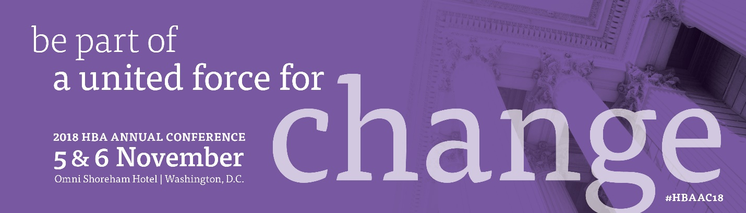

<Date>

Dear <Supervisor’s name>,

I am requesting your approval and support to attend the 2018 HBA Annual Conference in Washington D.C. in November.

When members of the Healthcare Businesswomen’s Association come together, it’s with a shared purpose: to be A United Force for Change; accelerating the impact and influence of women in the business of healthcare.

The conference is designed to provide content and opportunities for me to expand my skills and my professional network, both of which directly benefit <our organization> and improve my individual performance. More than 1,000 healthcare and life sciences industry professionals will gather to:
- build new and strengthen listing business connections
- learn from thought leaders to broaden our perspective
- expand our business skills and acumen
- support the HBA's mission to achieve gender parity in the business of healthcare

I have identified a number of educational sessions which will allow me to <insert benefits of attending topic specific sessions here. Suggestions provided below>. These sessions and presentations are led by industry experts and professionals known and recognized for their specific expertise.

This investment for my professional development is estimated as <$xxxx> which breaks down as follows:
- conference registration: <$xxxx>
- ground transportation: <$xxxx>
- hotel: <$xxxx>
- airfare: <$xxxx>

Please confirm your approval of my request by <date>. Registration for the program is now open seating is limited.

Thank you for your consideration,

Sincerely,
Suggestions for articulating the professional benefits associated with conference attendance :
- expand my industry knowledge
  - by increasing my understanding of AI and the implications on the industry
  - by improving my ability to leverage industry dynamics to accelerate our business results
  - by interacting with dozens of individuals from across the industry ecosystem
- improve my leadership effectiveness
  - by learning tips and techniques to recognize and eliminate gender bias in the workplace
  - by learning how to create an inclusive culture and environment which brings out the best in everyone
- improve my value and contribution to the organization
  - by improving my professional presence and the effectiveness of my communications
  - by identifying ways to better leverage mentors and sponsors to accelerate my career

Session and Exhibit Worksheet
Sessions:
I plan to attend the following sessions to strengthen my professional development. (List the sessions you plan to attend as well as the learning outcomes and how they will benefit you, your team, and your organization.)

Session Title/Speaker/ | Benefits and Learning Outcomes

Exhibitors:
I plan to visit the following exhibitors to gain more information on the solutions and services available that will help me do my job better. (If your firm is currently in the process of reviewing vendors, this is a perfect opportunity to set up an appointment to preview a demo.)

Exhibitor | Benefit of Visiting Exhibitor

