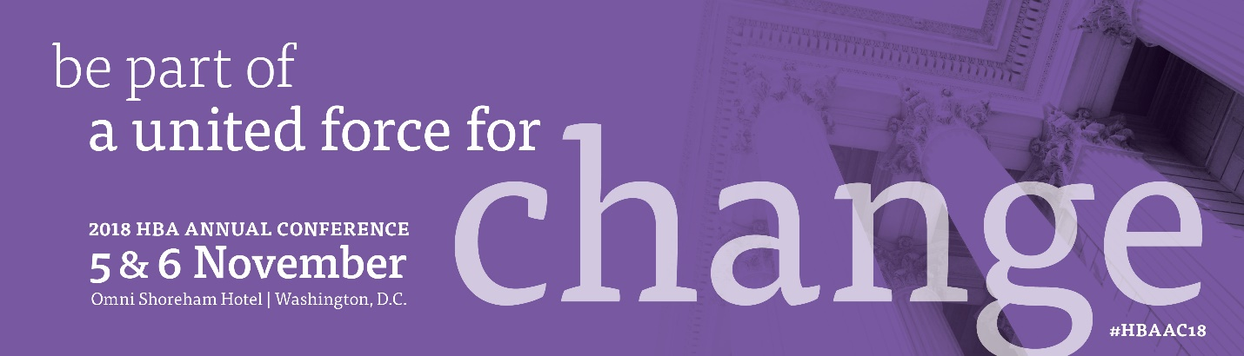

<Date>

Dear <Supervisor’s name>,

When members of the Healthcare Businesswomen’s Association come together, it’s with a shared purpose: to be A United Force for Change. As a long-standing leader in our organization, your commitment to this mission is well-recognized and much appreciated.
Please join us this fall in Washington, D.C. where more than 1,000 of our healthcare and life sciences industry corporate partners and members will gather to continue:
- building business connections for a sustainable leadership advantage for our industry
- hearing from thought leaders to broaden perspectives
- sharing and modeling your business acumen
- supporting the HBA’s mission to achieve gender parity in the business of healthcare

I have identified a number of educational sessions which will allow me to <insert benefits of attending topic specific sessions here>. These sessions and presentations are led by industry experts and professionals from around the world.

I am seeking your support to attend this conference. Here is the breakdown of conference costs:
- conference registration: <$xxxx>
- ground transportation: <$xxxx>
- hotel: <$xxxx>
- airfare: <$xxxx>

The total anticipated cost associated with attending this conference is: <$xxxx>.

Thank you for taking the time to review this proposal. By attending the Healthcare Businesswomen’s Association Annual Conference, the opportunity to further develop my skills, gain knowledge and establish key contacts will be a valuable investment for my professional development and what I will continue to bring to <insert name of your organization here>.

Sincerely,

Session and Exhibit Worksheet
Sessions:
I plan to attend the following sessions to strengthen my professional development. (List the sessions you plan to attend as well as the learning outcomes and how they will benefit you, your team, and your organization.)

Session Title/Speaker/ | Benefits and Learning Outcomes

Exhibitors:
I plan to visit the following exhibitors to gain more information on the solutions and services available that will help me do my job better. (If your firm is currently in the process of reviewing vendors, this is a perfect opportunity to set up an appointment to preview a demo.)

Exhibitor | Benefit of Visiting Exhibitor

