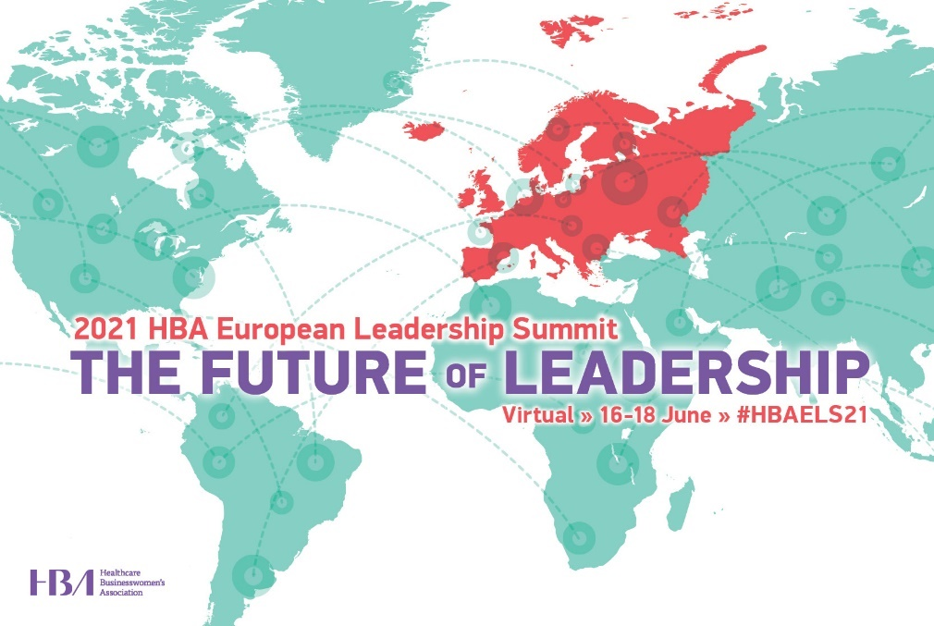
<Date>

Dear <Supervisor’s name>,

I am requesting your approval and support to attend the 2021 HBA European Leadership Summit.

When members of the Healthcare Businesswomen’s Association come together, it’s with a shared purpose: to be A United Force for Change; accelerating the impact and influence of women in the business of healthcare.

The virtual conference is designed to provide content and opportunities for me to expand my skills and my professional network, both of which directly benefit <our organization> and improve my individual performance. When the event has previously been held in person, more than 250 healthcare and life sciences industry professionals attended. The new virtual format should enable even more attendees to gather to:
- build new and strengthen listing business connections
- learn from thought leaders to broaden our perspective
- expand our business skills and acumen
- support the HBA's mission to achieve gender parity in the business of healthcare

I have identified a few educational sessions which will allow me to <insert benefits of attending topic specific sessions here. Suggestions provided below>. These sessions and presentations are led by industry experts and professionals known and recognized for their specific expertise.

This investment for my professional development is estimated as <$xxxx> for conference registration. The event agenda runs across three half-days from 16-18 June 2021.

Please confirm your approval of my request by <date>. Registration for the program is now open seating is limited.

Thank you for your consideration,

Sincerely,

Suggestions for articulating the professional benefits associated with conference attendance:
- expand my industry knowledge
  - by increasing my understanding of the disruptive trends in technology and the implications on the industry
  - by improving my ability to leverage industry dynamics to accelerate our business results
  - by interacting with individuals from across the industry ecosystem
- improve my leadership effectiveness
  - by learning tips and techniques to recognize and eliminate gender bias in the workplace
  - by learning how to create an inclusive culture and environment which brings out the best in everyone
  - by exploring the future of leadership and long-term strategies for talent development
- improve my value and contribution to the organization
  - by improving my professional presence and the effectiveness of my communications
  - by identifying ways to better leverage mentors and sponsors to accelerate my career

