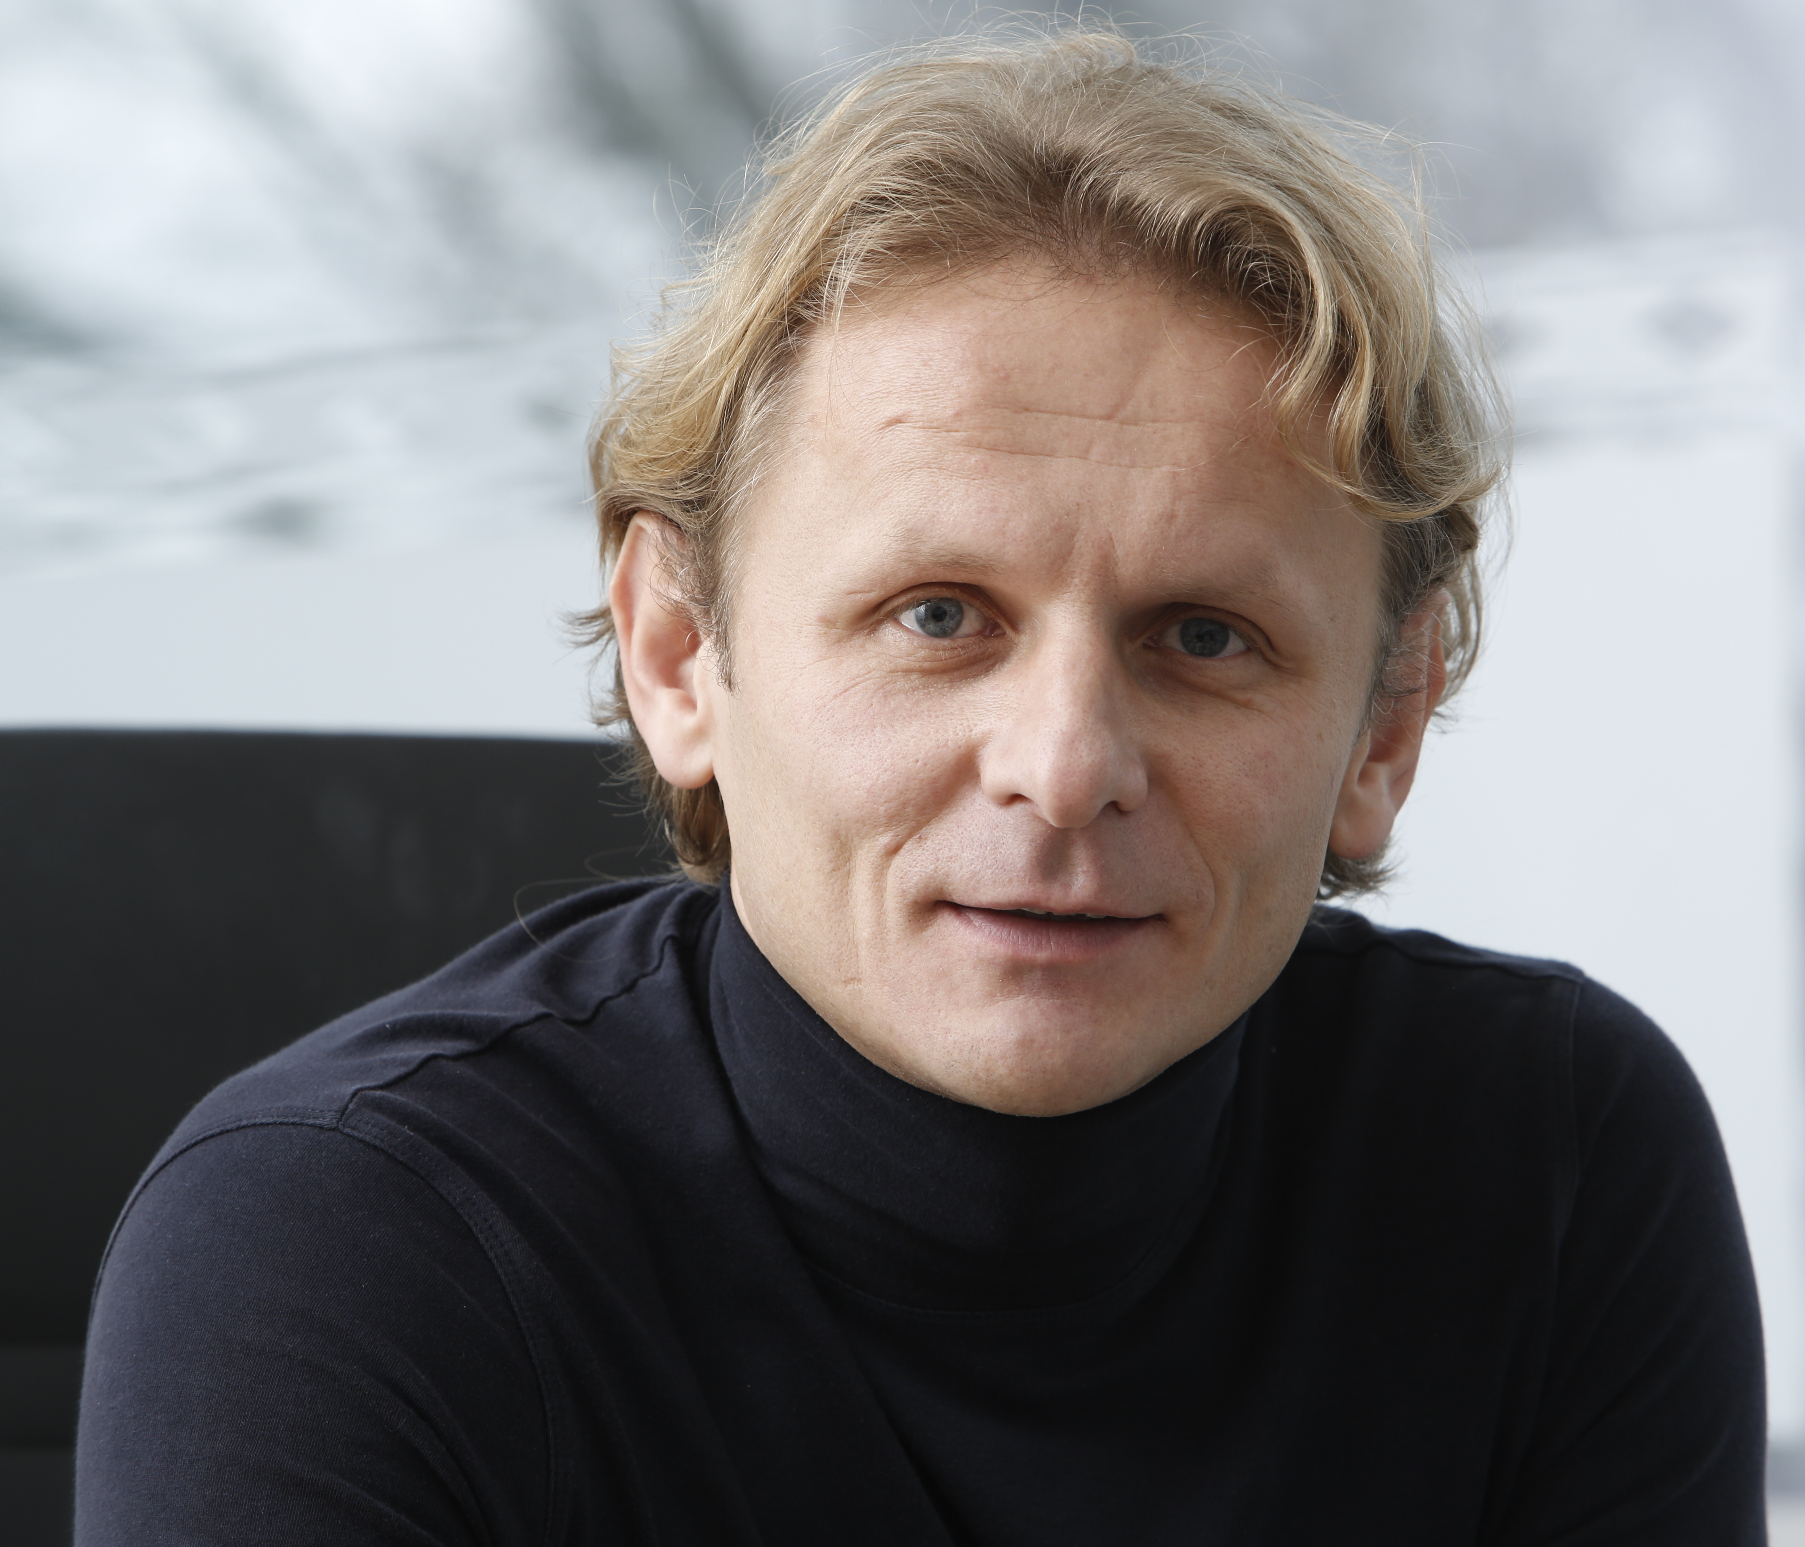
Ivan Dikic, Prof MD PhD
Professor and Chairman
Johann Wolfgang Goethe University
Institute of Biochemistry II
Theodor-Stern-Kai 7
60590 Frankfurt am Main
Email: ivan.dikic@biochem2.de
Webpage: www.biochem2.de
Phone: +49 (0) 69 6301 5652
Fax: +49 (0) 69 6301 5577

Ivan Dikic is Director of the Institute of Biochemistry II (IBC2) at Goethe University’s Medical School in Frankfurt. He also was the founding director of the Buchmann Institute for Molecular Life Sciences at Goethe University. Ivan Dikic was trained as a medical doctor in Zagreb (Croatia) and obtained his PhD working with Joseph Schlessinger at the New York University. From 1997-2002 he was a Group Leader at the Ludwig Institute for Cancer Research, Uppsala, Sweden.

Ivan explores molecular mechanisms of cellular signalling, which have a high relevance to human diseases such as cancer, neurodegenerative disorders and inflammation. Early on, he focused on ubiquitin and demonstrated how this small protein controls EGFR endocytosis, DNA repair, inflammation, cancer, infection and proteasomal degradation. His team has also provided insights in the networks controlling selective auto phagyof protein aggregates, pathogens and damaged organelles from the cell, thus shaping host-pathogen interactions and impacting on the development of neurodegenerative diseases like ALS.

Ivan is wholeheartedly dedicated to fostering scientific education and science popularization and for this work he has been awarded The Order of Duke Branimir bestowed by the president of Croatia. Ivan is an elected member of the German National Academy of Sciences Leopoldina, the European Molecular Biology Organization (EMBO) and the Academia Europaea. Ivan’s scientific achievements were honored with numerous awards, amongst them Award for Outstanding Achievement in Cancer Research by AACR, the Ernst Jung Prize for Medicine and the Gottfried Wilhelm Leibniz Prize (the highest scientific award in Germany).

