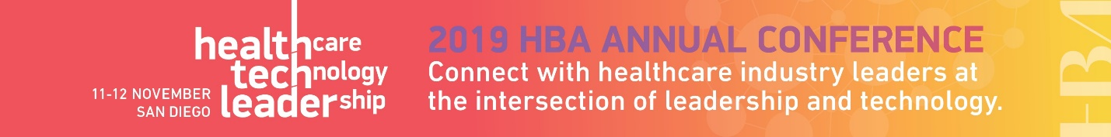

<Date>

Dear <Supervisor’s name>,

I am requesting your approval and support to attend the 2019 HBA Annual Conference in San Diego this November.

When members of the Healthcare Businesswomen’s Association come together, it’s with a shared purpose: to be A United Force for Change; accelerating the impact and influence of women in the business of healthcare.

At the intersection of technology, leadership and healthcare, the Healthcare Businesswomen's Association conference offers attendees unique educational and skill-building opportunities designed for me to expand my skills and my professional network, both of which directly benefit <our organization> and improve my individual performance. At this conference, I will:

- Learn best practices and practical solutions for solving industry-wide problems
- Hear from industry experts to break free from “how it’s always been” and radicalize my strategic thinking
- Build my network and represent <our organization> by connecting with industry leaders
- Engage my team, my tribe, my peers in uplifting and advocating for others
- Be empowered as a change agent, driving innovation throughout <our organization>

I have identified a number of educational sessions which will allow me to <insert benefits of attending topic specific sessions here. Suggestions provided below>. These sessions and presentations are led by industry professionals known and recognized for their specific expertise.

This investment for my professional development is estimated as <$xxxx> which breaks down as follows:
- conference registration: <$xxxx>
- ground transportation: <$xxxx>
- hotel: <$xxxx>
- airfare: <$xxxx>

Please confirm your approval of my request by <date>. Registration for the program is now open seating is limited.

Thank you for your consideration.

Sincerely,

Suggestions for articulating the professional benefits associated with conference attendance:
- Learn best practices and practical solutions for solving industry wide-problems
  - Increase my understanding of what others players are doing in the market
  - Gain a better sense of where we rank amongst our peers
  - Widen our view with key considerations brought to light by industry leaders
- Hear from industry experts to break free from "how it's always been" and radicalize your strategic thinking
  - Develop the skills necessary to better represent our team
  - Learn new tactics for driving innovation
- Build my network with peers and industry leaders
  - Chance to find a mentor, be a mentor
  - Develop or enhance my executive presence
  - Share my expertise with other HBA members
  - Build my community by connecting with senior industry leaders
- Be empowered as a change agent, driving innovation throughout our organization
  - Grow our company’s visibility for our commitment to women/gender parity
  - Obtain new resources and references to hot topics

Session and Exhibit Worksheet
Sessions:
I plan to attend the following sessions to strengthen my professional development. (List the sessions you plan to attend as well as the learning outcomes and how they will benefit you, your team, and your organization.)

Session Title/Speaker/ | Benefits and Learning Outcomes

Exhibitors:
I plan to visit the following exhibitors to gain more information on the solutions and services available that will help me do my job better. (If your firm is currently in the process of reviewing vendors, this is a perfect opportunity to set up an appointment to preview a demo.)

Exhibitor | Benefit of Visiting Exhibitor

